- To establish a Job Search Program Detail (PD), staff will update information on the Family Tab in The Workforce Information System of Texas (TWIST) ‘Reason for Care’ as ‘1- Employment’ and by choosing ‘blank’ in the ‘Child Care Referred by’ field:
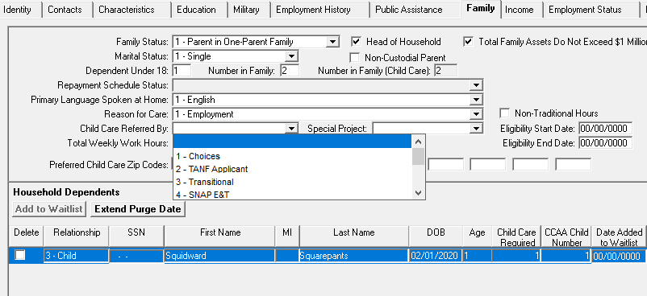

Next, staff choose ’12-Job Search’ from the ‘Special Projects’ drop-down menu:
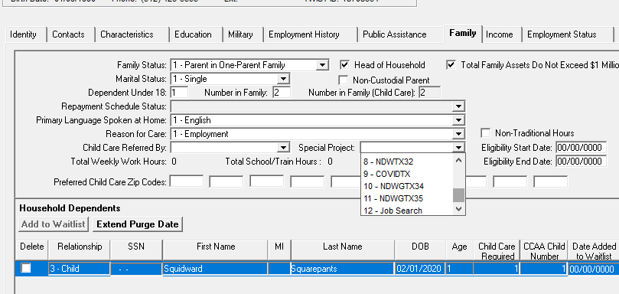

Note: Staff will need to save their progress as they move along the process of creating the new program detail.

The screen will look like this when the correct options are selected:

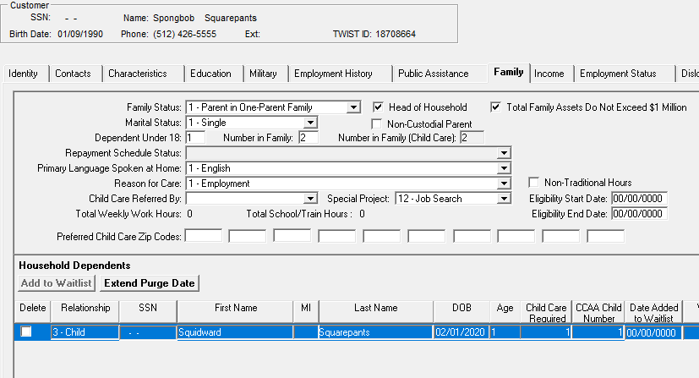
Note: Staff should verifiy that zero income is located in the Income Tab before creating the PD.

- To create the PD, staff navigate over to the Program Detail in Menu Selections and right click to add a new PD:

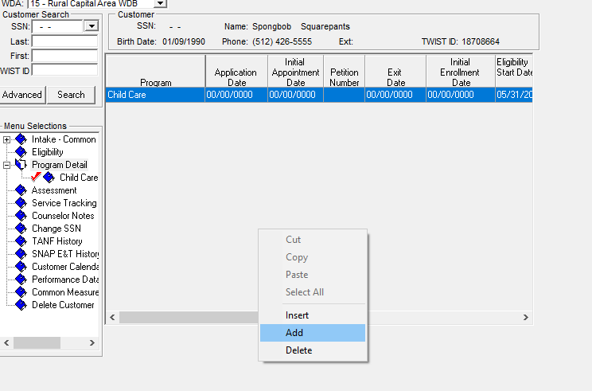

- When the next screen appears, staff select ‘16-Child Care’ from the ‘Program Type Cd’ drop-down menu and click ‘ok’:
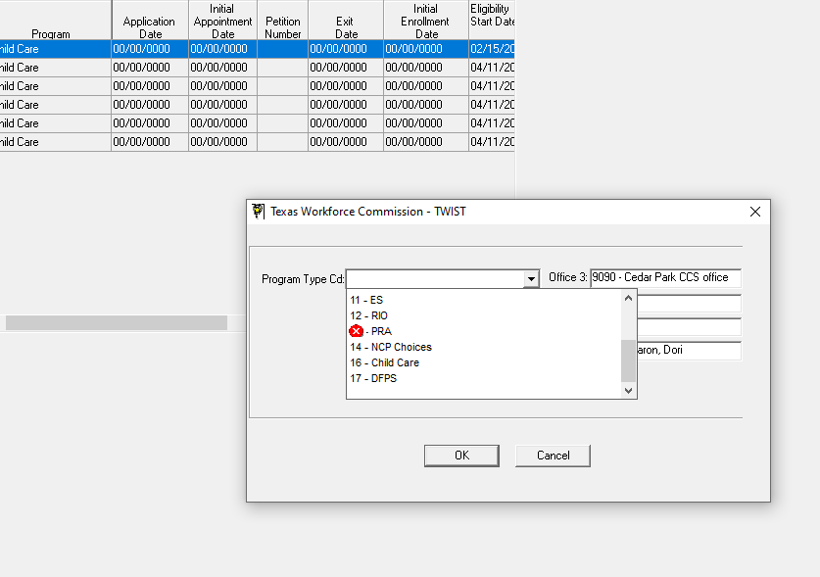

Next step is to select ‘Extended Year Exemption’ and choose ‘Yes’ from the drop-down menu and click ‘ok’:

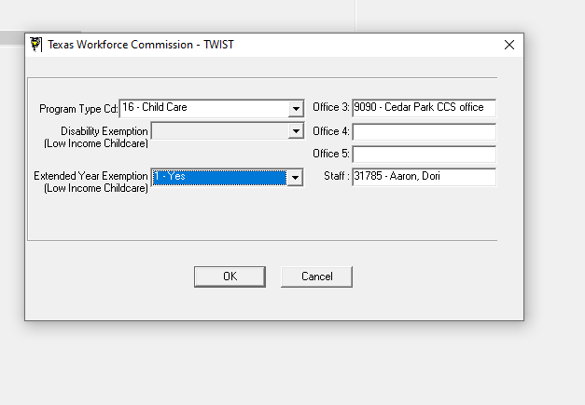
This will create the PD. The system will automatically default to 12 months so staff must change the end date manually. Staff must choose the correct eligibility end date based on the three months of child care allowed for initial job search:

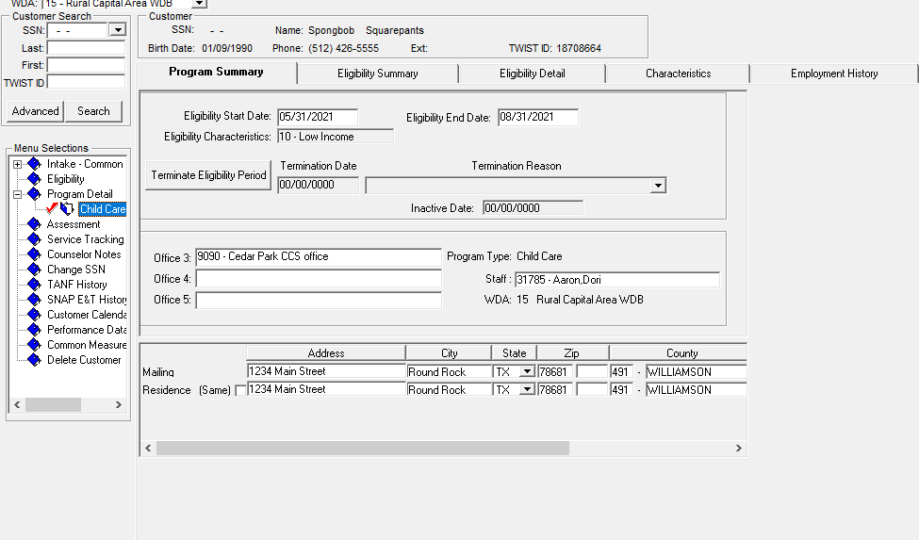
Note: When saving a PD for less than 12 months, a warning edit will appear notifying staff and staff will choose ‘Ignore and Save’ to proceed.

- Staff enter the child care referral information on the ‘Referral’ tab based on child care provider selection.

- Staff navigate to ‘Share of Cost’ tab and verify that authorized Parent Share of Cost (PSOC) amount displayed is zero. The amount that was initially assessed based on the Board’s Income table (highest amount for family size and children in care) should be clearly explained in a TWIST Counselor Note and also communicated to the family:

