Using the Online Financial Aid Application
CUSTOMERS
The purpose of this document is to help you navigate through the new online financial aid application. If you need assistance, please contact your closest Workforce Solutions office. You can see a list of offices by visiting https://www.wrksolutions.com/find-a-location.
To apply for financial aid, you must complete the following steps:
- Agree to speak with a Workforce Solutions Professional about your request for financial aid.

Customers applying for scholarships are required to complete an assessment with a Workforce Solutions professional. This assessment will help to identify your goals and build a plan to meet your educational needs.

- Go to https://www.wrksolutions.com/instructions
The Apply for Financial Assistance screen displays.
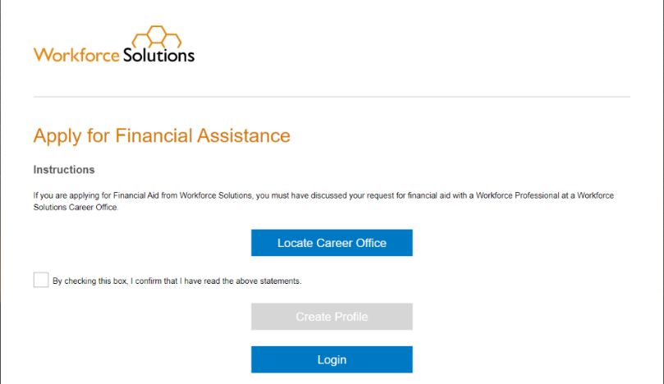
- Check the box agreeing to discuss your request with a workforce professional at a Workforce Solutions office. This will activate the “Create Profile” button. Click on Create Profile.
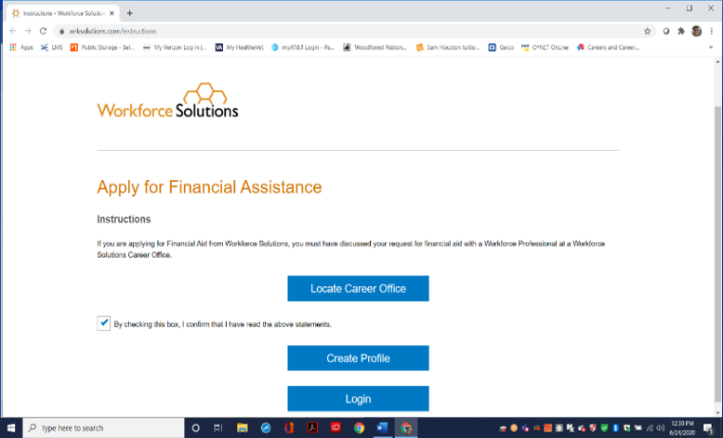

- Create a Profile
The Profile screen displays.
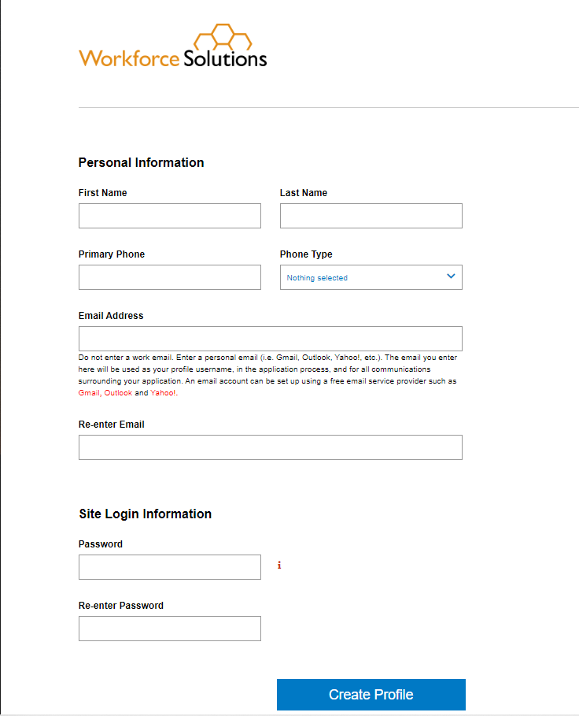
Enter the required contact information:
- Name
- Phone number
- Email address

NOTE: If you do not have an email address, you can create one by clicking on the link to your preferred email provider below the email address field and completing the setup process for the provider.
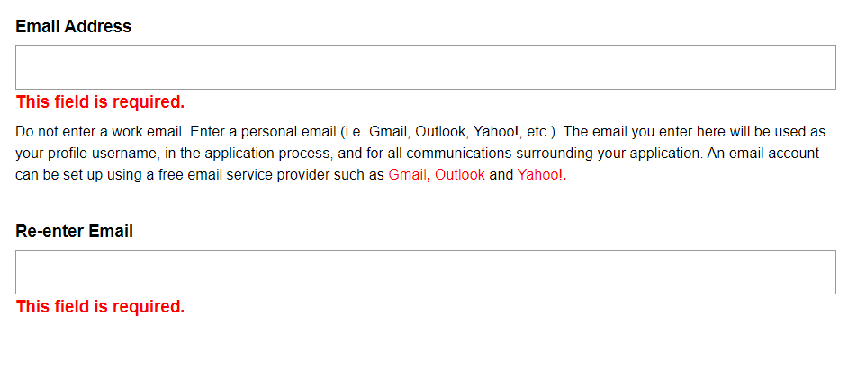
A secure password must contain at least:
- eight (8) characters
- one uppercase letter
- one lowercase letter
- one number
- one special character (! @ # $ % ^ & *)
When all information is entered, click the Create Profile button. The Verify Email Address screen displays.

To confirm and verify your email address:
- Click the Send Verification Email button. A verification email will be sent to the email address you listed.
- Login to your email address.
- Retrieve the verification email from WFSFinancialAid@wrksolutions.com.
Note: If the email is not in your inbox, check your Spam folder.
- Click the VERIFY link in the verification email.

- The Email Verified screen displays.
- Click the Continue button. The Welcome/Services page displays.
To continue the application profile:
- Check the applicable box(es) to identify the services you are requesting.
- Agree to an assessment within 14 days by clicking, I Agree.
- Answer the questions on the Financial Assistance page and click Next.

- Complete the application and upload supporting documents.
The Financial Assistance – Getting Started page displays.
At this point, you may choose to logout and return to complete the application at a later time.
IMPORTANT NOTE: If an application is not submitted within 14 days, you will have to reenter your application information in your profile.
To continue, click Application Progress. The Application Progress screen displays seven steps to complete. For each step, you must answer a series of questions and click Next at the end of each page. Once you complete a section, the Complete Section button displays. At this point, you can click on the Save & Logout button, save what you’ve done, and return to complete the application at a later date.
Note: If a step has been completed, a link to ‘Edit’ the information displays in place of the Start button.
Once all sections have been completed, click the Complete Section button to save the information.
NOTE: If you are a Veteran, you must complete the Veteran Addendum.
The Family Information screen displays. You can choose to logout and return to the application at a later time by clicking the Save & Logout button at the top of the screen. Family Information
You must provide information about your household members and your own and family members’ employment, income, and public assistance.
If a family member requires childcare, the Addendum for Childcare Assistance page displays for you to enter your selected child care provider information. If you haven’t chosen a provider, you have the option to click Next to continue.
The Addendum for Child Care Assistance (Parent Agreement) displays.
The Parent Agreement is made up of two pages. For each page, you must read and agree to each statement by clicking the check box next to “I Agree” and clicking the I Accept button at the bottom of each page.
The Documentation page displays.
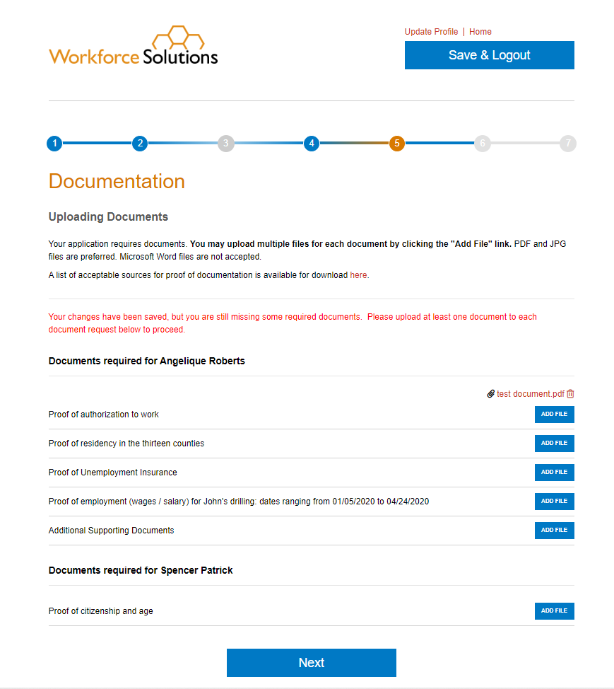
- Documentation
Based on the services you are requesting, you must upload documentation which support the information you’ve provided in the application. A list of required documents displays on the page.
Note: Only .pdf and .jpg versions of documents can be uploaded. If you have difficulty uploading your documents, please contact a Workforce Solutions professional for assistance.
To add a file:
Click Add File next to the document type. The file navigator pop-up window displays, allowing you to locate the document on the computer. Select the document by double-clicking on it or clicking the Open button. The document is uploaded and displays to the right of the document type. You will need to complete the steps to add files over until you have uploaded all required documents. When all documents are uploaded, click Next to continue the application.
NOTE: To continue the application, required documentation must be uploaded. You may click the Save & Logout button to stop the application, gather the documents, and return later. To see a list of acceptable documents for child care, click here. To see a list of acceptable documents for scholarship, click here.
The Orientation to Discrimination Complaint Procedures page displays.
- Orientation to Discrimination Complaint Procedures
The Orientation to Discrimination Complaint Procedures form addresses discrimination complaint procedures for the programs and services Workforce Solutions offers, including:
- Workforce Innovation and Opportunity Act (WIOA)
- Temporary Assistance for Needy Families (TANF)/CHOICES
- Supplemental Nutrition Assistance Program Employment & Training (SNAP E&T)
- Child Care Services (CC)
- Trade Adjustment Assistance (TAA) and Trade Readjustment Allowances (TRA)
Click I Accept to acknowledge you have read and agree to the information in the document. The Disclaimers page displays.
- Disclaimer
You must read and agree to the disclaimers on the page by clicking the box next to each statement and choosing the current date. Statements include:
- I understand that providing false information or failing to disclose information in order to appear eligible for financial aid is considered fraud. A person, who obtains, or attempts to obtain by fraudulent means, services to which the person is not entitled, may be prevented from receiving future financial aid from Workforce Solutions, must pay back financial aid received, and may be prosecuted under applicable state and federal laws.
- I give permission to Workforce Solutions to contact third parties to verify information pertaining to my application for financial aid.
- I certify that my answers are true and complete to the best of my knowledge.
- I read and signed the Orientation to Discrimination Complaint Procedures form.
By selecting the "I Accept" button, you are signing the Agreement electronically. You agree your electronic signature is the legal equivalent of your manual signature on this Agreement.
Click the I Accept button to continue.
- Submit application for approval.
The Final Review page displays.
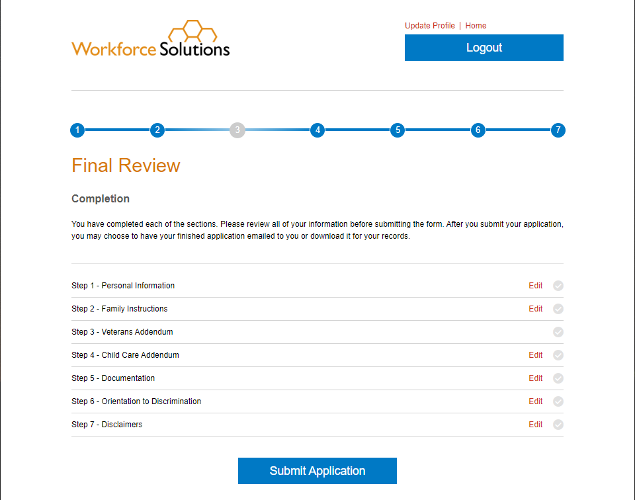
You have the option to review all the information entered by clicking the Edit link next to each step. When you are satisfied all information is complete, click the Submit Application button. The Social Security Number pop-up displays.

Providing a Social Security Number (SSN) is optional. You can enter your SSN and click Submit or click on Skip.
The Application Submitted page displays, informing you the application has been submitted. You may choose to download a copy of the application or have it emailed for your records.

