Korn Ferry Career Transitioning Services (CTS)
Data Entry Desk Aid

Career Transitioning Services (CTS) are available to RESEA and other eligible customers through Korn Ferry. Korn Ferry will provide customers with structured job-seeking support, access to online resources, and chat-based career advisors. Korn Ferry services will be available for six months from the date of customer registration.

Workforce Solutions staff must enroll customers in CTS through WorkInTexas.com no later than January 27, 2023. To receive six months of services, customers must register no later than March 31, 2023.

- RESEA Customers
Korn Ferry CTS is voluntary for RESEA claimants, and, therefore, if a customer chooses not to access these services, his or her unemployment insurance (UI) benefits will not be affected. Additionally, as of August 15, 2022, Korn Ferry CTS is considered an acceptable work search activity for all UI claimants, including RESEA customers.

Workforce Solutions staff working with RESEA customers must:
- Explain to the customer that they may record each hour involved in Korn Ferry CTS workshops or career coaching activities as a work search activity in their UI Work Search Log.

- Provide RESEA services according to the WS 20-06 Rapid Reemployment – Back to Work regardless of whether the customer receives CTS through Korn Ferry.

- Complete the following steps to enroll all RESEA customers in the Korn Ferry CTS program on the same day as the required one-on-one RESEA services, even if the customer chooses not to register with Korn Ferry to receive services:
- Verify and document the following criteria in WorkInTexas.com:
      - The RESEA orientation letter
      - The customer’s identity through the completion of List B in the WIOA Authorization to Work form
      - The customer’s age
      - Selective Service registration, as applicable, for male customers
      - Signed Orientation to Complaint

- Enroll the customer in the Korn Ferry CTS program by:
    - Creating or editing the Wagner-Peyser participation record in WorkInTexas.com; and
    - Selecting KF CTS – RESEA from Special Project/Indicators options on the Miscellaneous tab of the Wagner-Peyser application. (See Appendix 1)

- Upload eligibility documents in DocuWare and WorkInTexas.com through the Documents (Staff) tab (See Appendix 2)

- Enter service VGS – (97, VGS) Career Guidance Services in WorkInTexas.com and attach a note including the statement “RESEA claimant eligibility determined and referred to KF CTS.” (See Appendix 3)

- Confirm that the customer has a unique (not shared) email address in WorkInTexas.com or help the customer obtain such an email address. (TWC will use this email address to send the customer a registration link for CTS.)

- Inform the customer that he or she will receive a notice from TWC in the form of a GovDelivery email to register for CTS.

- Other Eligible Customers
Workforce Solutions staff may refer interested non-RESEA customers (including other UI claimants, Rapid Response attendees, and customers receiving Substantial Assistance) to enroll in the Korn Ferry CTS program if determined eligible.
- Workforce Solutions staff must determine eligibility for individuals (excluding RESEA customers) by completing the following steps:
- Conduct an eligibility determination by verifying and documenting the following criteria in WorkInTexas.com:
    - Eligibility to work in the United States (completed WIOA Authorization to Work form)
    - The individual is 18 years of age or older
    - Selective Service registration, as applicable, for male participants
      - Signed Orientation to Complaint document

- Confirm that the customer has a unique (not shared) email address in WorkInTexas.com or help the customer obtain such an email address (TWC will use this email address to send the claimant a registration link for CTS.)

- Workforce Solutions staff enroll eligible individuals (excluding RESEA customers) in the Korn Ferry CTS program by completing the following steps:
- Create or update the Wagner-Peyser participation record in WorkInTexas.com.

- Select KF CTS – Other from the Special Project/Indicators options on the Miscellaneous tab of the Wagner-Peyser application. (See Appendix 1)

- Upload eligibility documents in DocuWare and WorkInTexas.com through the Documents (Staff) tab (See Appendix 2)

- Enter service VGS – (97, VGS) Career Guidance Services in WorkInTexas.com and attach a note including the statement “Individual eligibility determined and referred to KF CTS. Not RESEA customer.” (See Appendix 3)

- Inform the customer that he or she will receive a notice from TWC in the form of a GovDelivery email to register for CTS.

Appendix 1: WIT Steps to Enroll Customer in Korn Ferry CTS Services

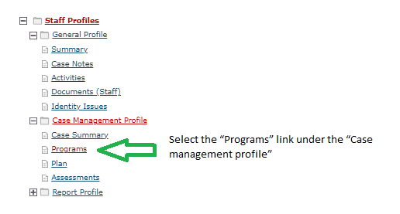

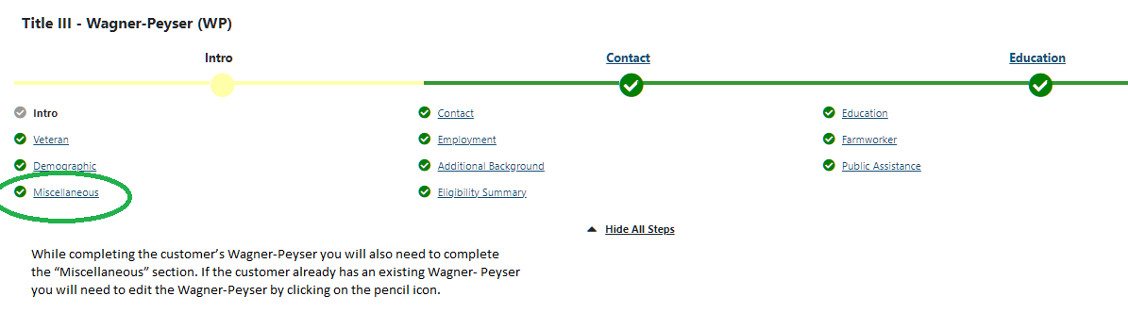

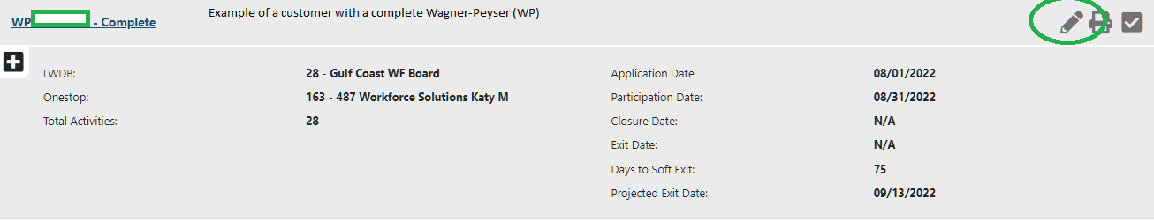

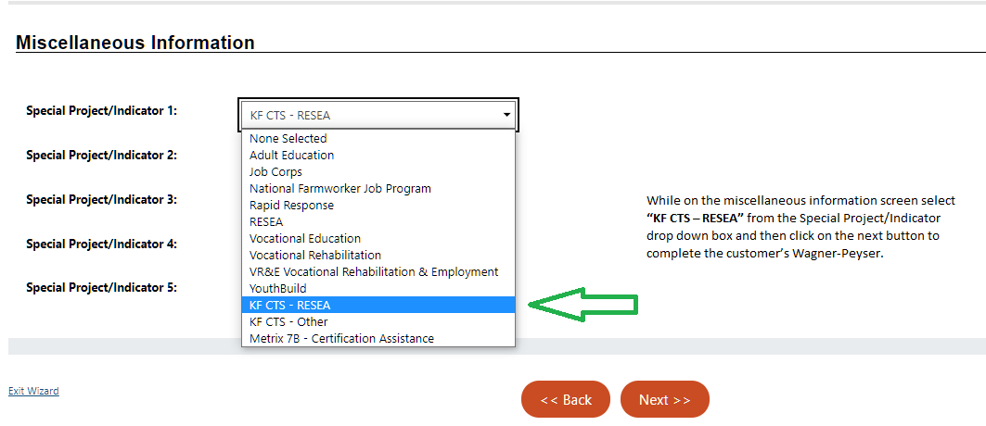

Appendix 2: Uploading Documents in WIT

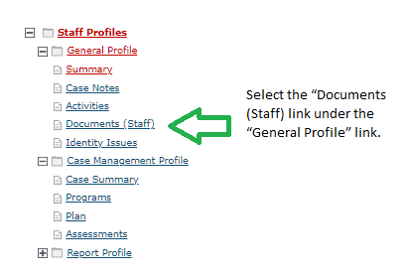

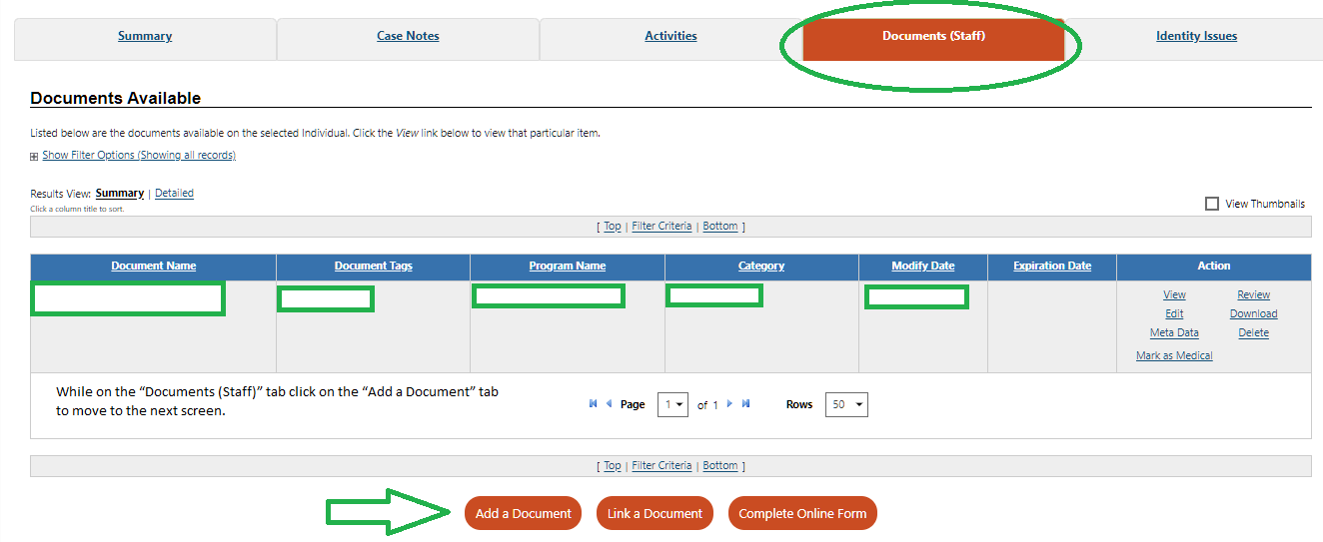

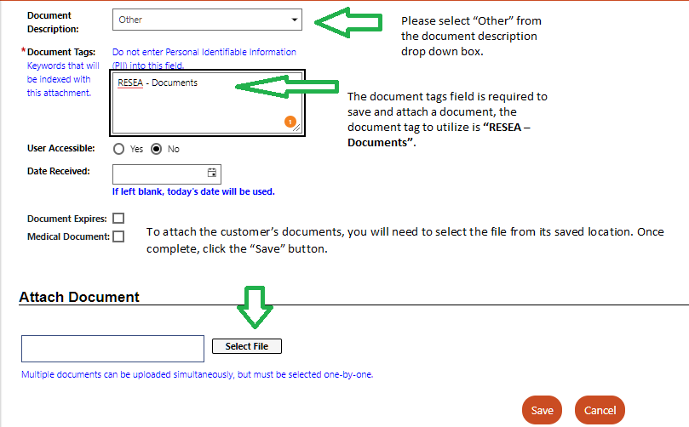

Appendix 3: Entering VGS – (97, VGS) Career Guidance Service in WIT

