Ms. Williams came to Workforce Solutions September 2016 as a Program Assistant. Ms. Williams is always willing to go the extra mile without being asked, always wanting to provide a resource to each customer she meets and willing to help the office at any capacity she can. Ms. Williams is viewed as one of our upcoming leaders at the Astrodome office. Ms. Williams is always pleasant, she always has a smile on her face and willing to help everyone. The Astrodome office can call on Ms. Williams to represent Workforce Solutions for any event. Ms. Williams started off as a Program assistant, however due to dedication and hard work, she was promoted in November 2016 as a Personal Service Representative, which she loves working with customers helping them reach their goals. Ms. Williams is an enthusiast, innovative and resourceful Personal Service Representative in the Astrodome office. Ms. Williams engages all of her customers, regardless to their age, sex, socio-economic background, work experience or skill level. Ms. Williams has been a team player within the group.
Ms. Williams works with the Professional Academy Career Exploration program, an initiative with Worthing High School and the City of Houston providing year round employment, career exploration and enrichment activities for 12 students. Ms. Williams case manages the students and acts a mentor to each student , she is there to answer any questions or needs the students may have. Ms. Williams has been able to relate to the students. She has built a rapport with the students that has helped them to meet their educational goals. All the students she has mentored have been accepted into college. She has worked with other residents giving them thorough and detailed information on how they can meet their employment goals. She is encouraging, patient and positive with all customers.

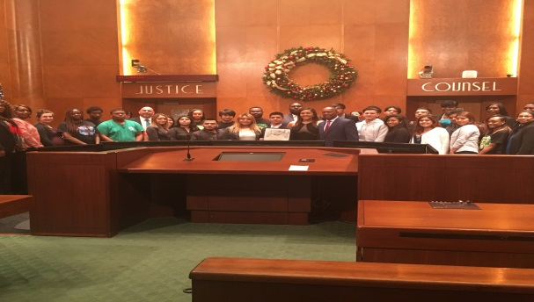
Ms. Williams is very flexible in office operations. She is always willing to step in to any position that is required of her. She takes the initiative when she sees an area that needs attention. She is willing and available for management staff. She is willing and available for her co-workers (PSRs, ECs, and Program Assistants.
Ms. Williams exhibits qualities and traits of a leader. She has the ability to look at the big picture within the organization. She provides World Class customer service with each customer she interacts with. Ms. Williams exhibits the 5 principles of I am Workforce Solutions every day to each customer she meets, utilizing the customer’s perspective, understanding resources, always assist customers when she has to say NO, and learning from any mistake made. As a result I would like to nominate Ms. Williams for I am Workforce Solutions.

