AT/AA Matrix Description | Brand | Use | Location | Picture / Details
Screen Magnifier | MAGic | Magnify computer screen; change background and text colors | Every Accessible Workstation
Screen Narrator | JAWS | Read text on computer screen | Every Accessible Workstation
Embedded Screen Magnifier & Narrator | Ease of Access | Similar to MAGic and JAWS, but with fewer options | Every computer with Windows Operating System
Headphones |  | Privacy while listening to sound from computer |  | 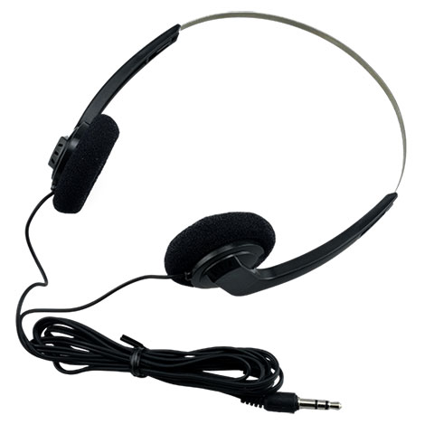
Large Print Materials |  | Individuals with vision impairments | Available upon request | Copy machine (if paper); MAGic or JAWS (if electronic); VRS partners (if need braille or print larger than possible from copy machine)
Qualified Staff Readers |  | Individuals with vision impairments, intellectual or learning disabilities | Available upon request | Any staff person that can read to a customer if needed
Large Print Keyboard | can be stickers | Individuals with vision impairments | Every Accessible Workstation | 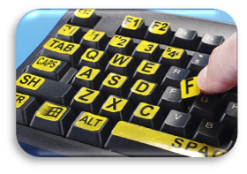
Braille Signage |  | Identify rooms for individuals with vision impairments | Latch side of door at all Permanent Rooms | 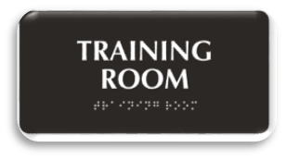
AT/AA Matrix Description | Brand | Use | Location | Picture / Details
Fire Alarms w/ Visual and Auditory Alert (may be exempted by Fire Marshall) |  | Alert all individuals of fire |  | 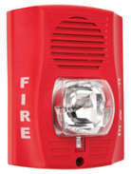
Magnifying Glass (optional) |  | Individuals with vision impairments
Braille Keyboard (optional) |  | Individuals who use braille |  | 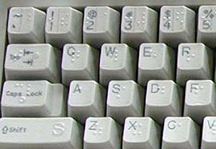
Trackball Mouse |  | Individuals with mobility impairments | Every Accessible Workstation | 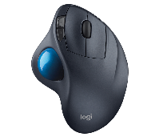
Adjustable Height Table |  | Individuals with mobility impairments, dwarfism, or gigantism |  | 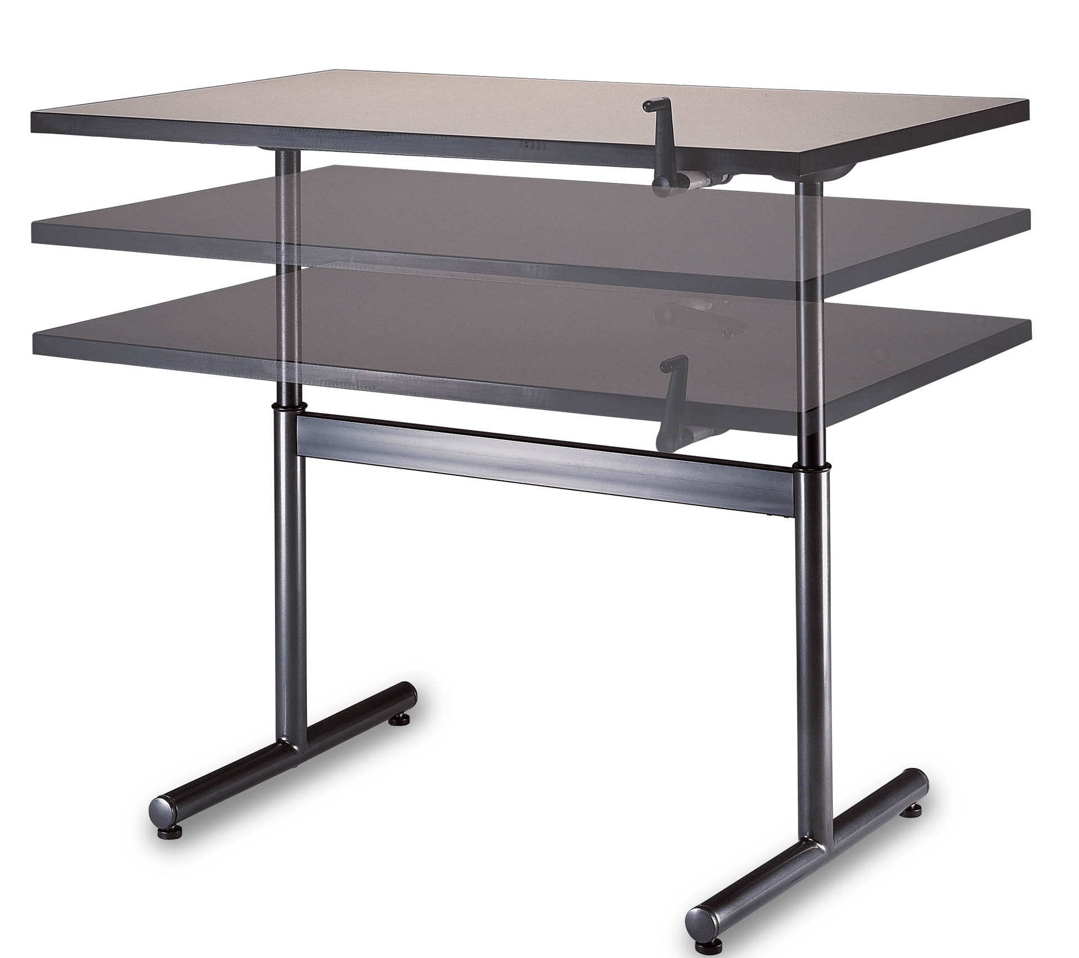
Adjustable Height Chair |  | Individuals with mobility impairments, dwarfism, or gigantism | Every Accessible Workstation | 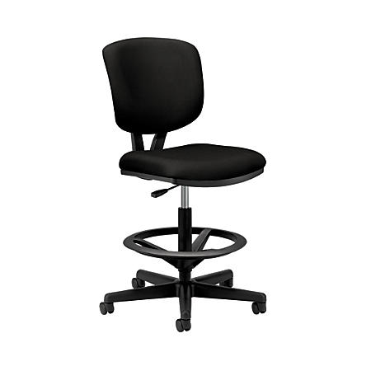
Accessible Printers and Copiers |  | Individuals with mobility impairments, dwarfism, or gigantism |  | No higher than 48” to reach buttons, printouts, etc.
Speech Amplification System | Pocketalker | Amplify voices while blocking out background noise |  | 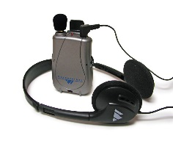

AT/AA Matrix Description | Brand | Use | Location | Picture / Details
Multiple Internet Browsers | Internet Explorer, Google Chrome, Mozilla Firefox | Individuals with cognitive impairments | Every Accessible Workstation
Quiet Workspace (optional) |  | Anyone who needs to be away from distractions |  | Office, cubicle, or room where an individual can work away from normal office traffic
Phone with Volume Control |  | To raise or lower the volume of the voice coming through the phone |  | 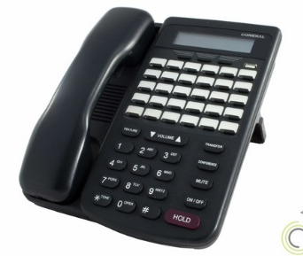
Phone with T-Coil Insert |  | To prevent feedback for an individual with a hearing aid;  Hearing Aid Compatible (HAC) |  | 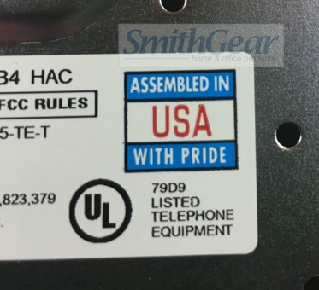
TTY Telephone |  | Typing out phone conversations for individuals with hearing impairments or speech impediments |  | 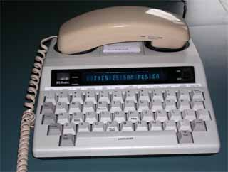
Relay Texas Service |  | To be used with TTY
Written Materials for Orientations and Workshops |  |  |  | Folders, workbooks, or other written materials

AT/AA Matrix Description | Brand | Use | Location | Picture / Details
Sign Language Interpreters | Language Line | Individuals who use sign language to communicate and sometimes LEP individuals
Video Relay Services | Sorenson | Interpreter assisted phone calls for individuals who use sign language to communicate |  | 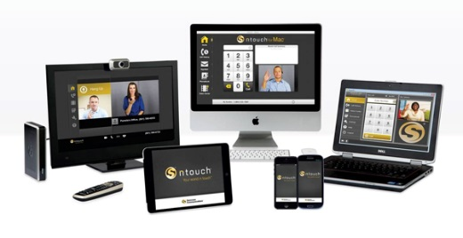
Visual or Tactile Pagers |  | To alert individuals a staff person is ready to work with them
Bi-lingual Staff |  | Individuals with limited English proficiency (LEP) |  | Be sure all staff are aware of which staff can speak, read, and/or write another language
Telephonic Language Interpreting | Language Line | Individuals with limited English proficiency (LEP)
Other Interpreter/Translation Services | Google Translate; Community Partners | Individuals with limited English proficiency (LEP)
Braille WIOA Notices |  | Individuals who read braille | Greeter Station | English and Spanish
I Speak Cards |  | Individuals with limited English proficiency (LEP) | Greeter Station

