Click on ‘Report Category’ button, then click ‘Child Care’ category….

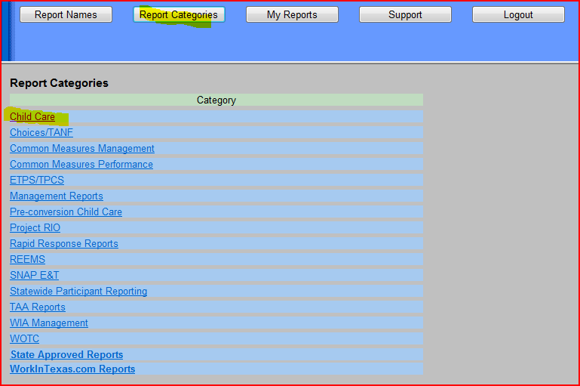

The list of available Child Care reports display as shown below:

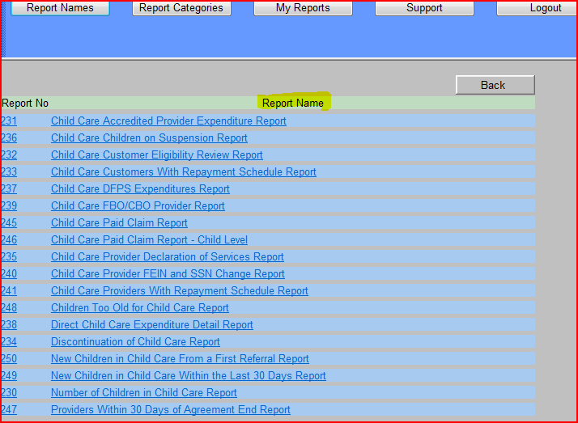

Then select the individual Report name from the list that you want to submit a report.

All reports based on Child Care data before the conversion to TWIST have been placed in a new report category, "Pre-Conversion Child Care".

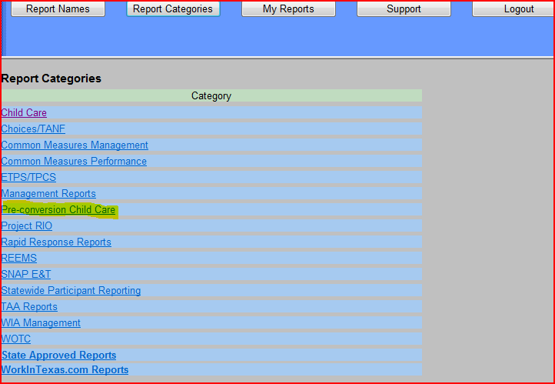

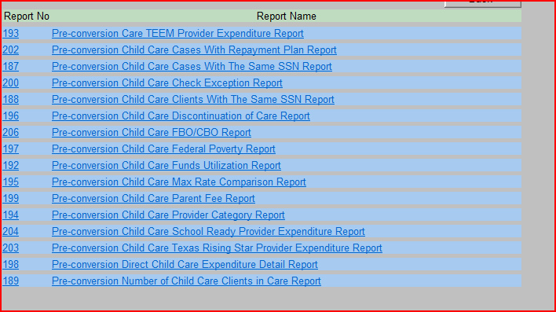

SUPPORT tab

Includes:

