

**Latrell odems**

Greeter- Pasadena

pROPOSAL

## telephone: 713-472-1608 | facsimile: 713-472-1275 | email: Latrell.Odem@wrksolutions.com

address: 103 Pasadena Town Square Mall | Pasadena, Texas, 77506

website**:** www.webaddress.com

**I propose a faster more convent way for customers to gain Hire event information.**

**SITUATION**

Often customers asked what other job fairs are taking place on that particular day. Customers are directed to our website (wrksolutions.com) were they can get several option of hiring events for that particular Day/Week. This is a three step process to retrieve this information. Without assistance customers are often confused.

**Proposed Solution**

* To enhance what’s already available online, making events easily accessible on our home page as well as WIT (Work In Texas).
* Allow customers to filter by office.
* A Visual Screen showing Job Fairs Information once entering database.
* Text Messages for Industry Specific Job Fairs.

**Benefits**

* Customer Satisfaction.
* More Qualified applicants would attend Job Fairs.
* Improved Marketing for events.

**Step Involved**

* Upgrades to our databases.

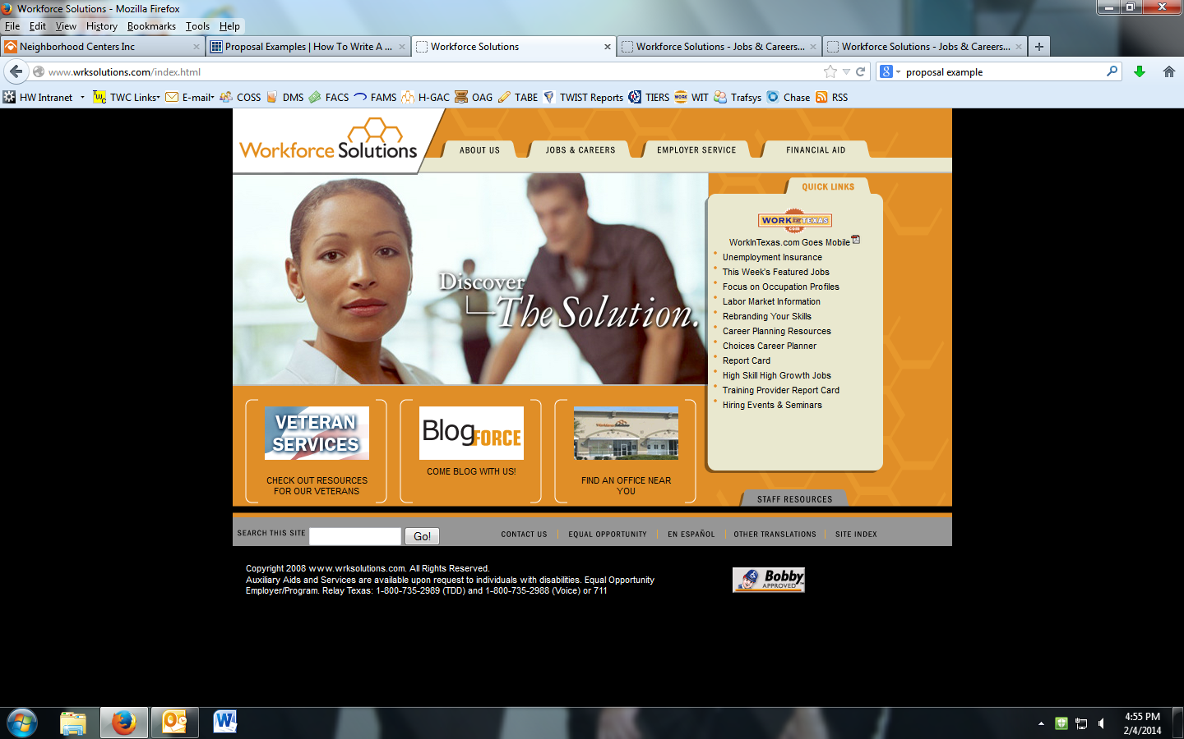

**Cost**

Unknown