**Omnilert**

Registration Directions

Omnilert is a communication tool used to provide critical information to Workforce Solutions’ staff during emergency situations. To receive alerts, you will need to register in the Omnilert system and update your profile as needed. Please follow the steps below.

* Go to: <https://h-gac-ws.omnilert.net/>
* Select: “SIGN UP”

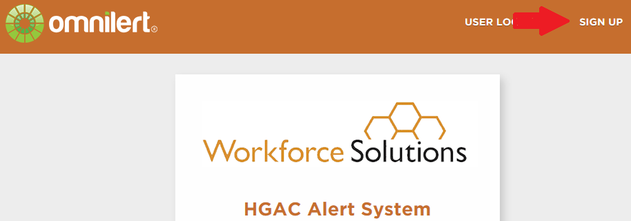

* Complete the “Sign Up” page

o Select ONLY one group (Contractor/ Provider Name)

* Services Page

o When creating a profile, enter your phone number or sign up using email.

o A validation will be sent to verify your preferred method of communication.

You must repeat the validation process for each method of communication desired.

**Omnilert**

Forgot username? / Forgot password?

* Go to: <https://h-gac-ws.omnilert.net/>
* Select: “USER LOG IN”

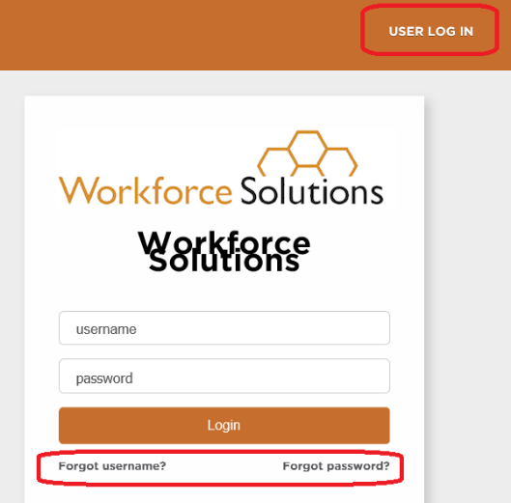

**For individuals who forgot username**

* Select “Forget username?”
* Complete the requested information

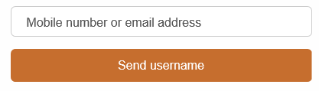

If you are a valid user for this account, an email will be sent to you with your username.

**For individuals who forgot password**

* Select “Forget password?”
* Complete the requested information

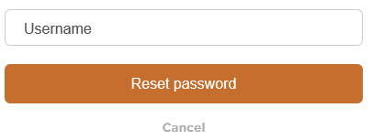

* If you are a valid user for this account, an email will be sent to you with a link to reset your password.

Updated: 6.3.20