Using DocuWare To Manage Workforce SolutionS’ files

Career Office

Houston-Galveston Area Council

***Workforce Solutions © 2015***

***Version 1.0, 3/9/15***

**Workforce Solutions is an equal opportunity employer/program. Auxiliary aids and services are available upon request to individuals with disabilities.**

**Texas Relay Number:**

**1-800-735-2989 (TDD) 1-800-735-2988 (voice)**

# **Table of Contents**

* **Introduction 5**
* **Log onto DocuWare 5**
* **Change Password 6**
* **Connect DocuWare Desktop Applications 7**
* **Enter Documents into DocuWare 8**
* **Scan 8**
* **Drag and Drop 9**
* **Import Files 12**
* **Store 13**
* **Locate Customer Records 15**
* **Edit Indexes 17**
* **Add Office Notes to a Document 18**
* **Office Action Needed List 18**
* **Working in the Document Tray 19**
* **Combine and Separate Documents 19**
* **Staple 21**
* **Glossary of Terms 22**

**NOTES**

# **Introduction**

DocuWare is a web-based document management system that allows Workforce Solutions staff to transmit, share, store, and retrieve documents such as financial aid applications, eligibility documents, and tracking paperwork. Using DocuWare allows staff to assist customers in a timely and efficient manner. It also helps staff throughout the system communicate more effectively regarding customer records.

**Log onto DocuWare**

DocuWare

To log onto the DocuWare system, enter https://[DocuWare.wrksolutions.com](http://www.docuware.wrksolutions.com) in your web browser address bar. *Save the address on your desktop or as a Favorite on your taskbar.*

1. Enter your Username. *Usernames are not case sensitive.*
2. Enter your password. *Passwords are case sensitive*\*.
3. Click Login.

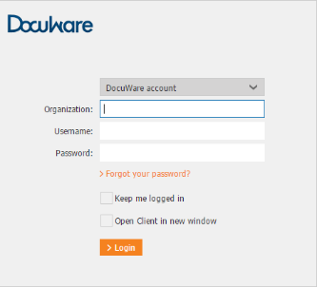

*As a first time user select ‘>Forgot your password?’ to change the setup password.

1. Enter your Username.
2. Click Send. DocuWare will send an email link to your wrksolutions email address.
3. Click the link. You will be redirected to a Change Password page.

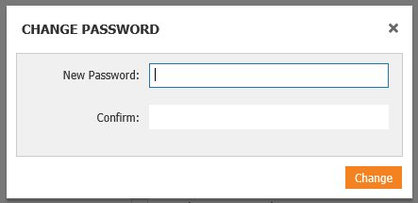

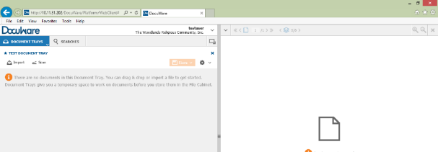Your password must be at least six characters long and must contain at least one upper case letter, one lower case letter, and one number. Your DocuWare workspace displays. The workspace is unique based on the permissions assigned to you.

Dashboard

Viewer

You can duplicate your Dashboard by clicking on the Show Split Pane icon at the top right of the Dashboard.

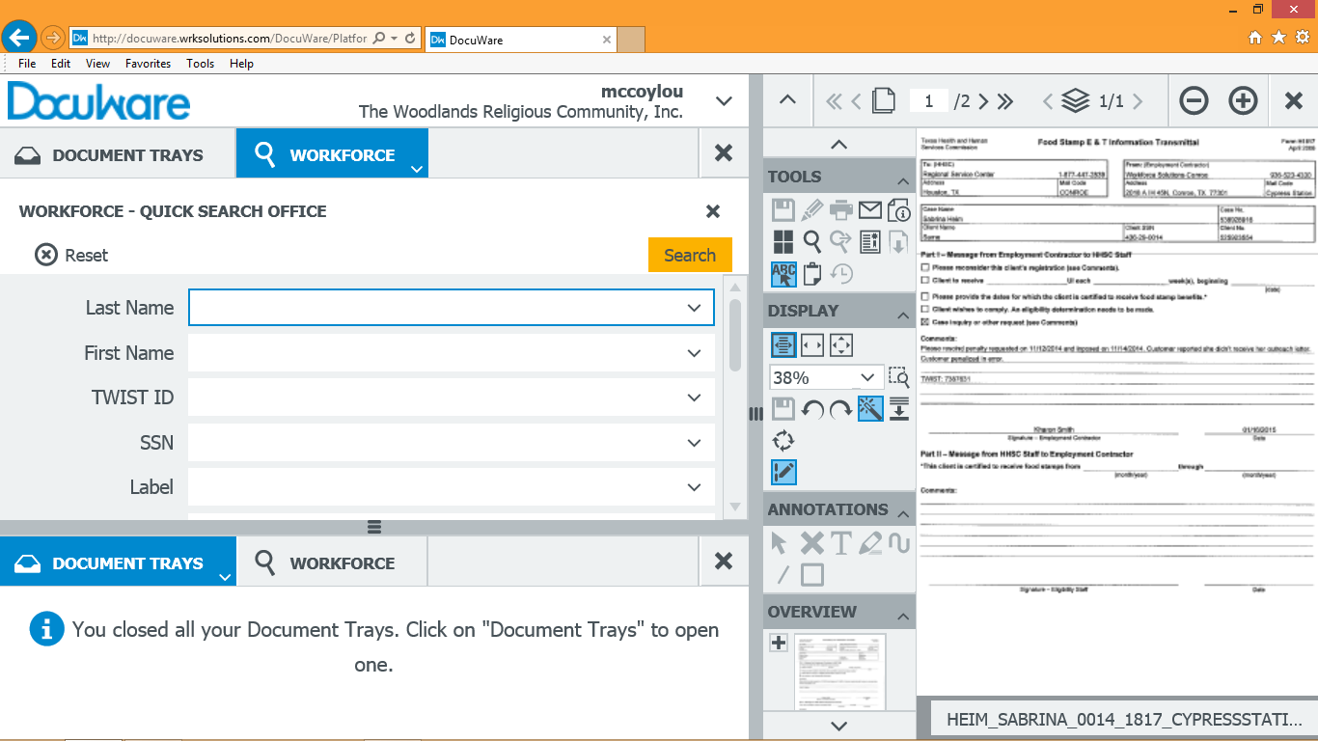

# Connect DocuWare Desktop Applications

DocuWare provides additional applications (apps) for download that allow actions such as dragging documents directly into DocuWare, using Windows Explorer to manage documents, and importing files directly from network scanners. While the apps are not required to use DocuWare, they make some tasks easier and more efficient. The apps must be downloaded to your computer by your contractor IT department. The first time you log into DocuWare after the apps are installed, you must connect to the apps to use them. If you use multiple computers, repeat the process for each computer you use.

1. 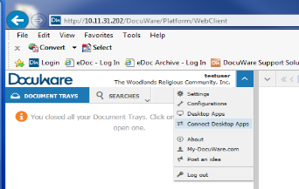Click on the arrow to the right of your user name. A dropdown menu displays.
2. Select Connect Desktop Apps from the dropdown menu.
3. A pop-up window displays with the message: Do you want to allow the requesting application access to your local DocuWare services?

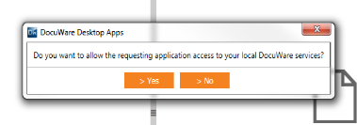

1. Select Yes. A pop-up displays acknowledging your successful connection.

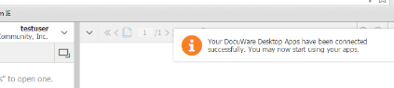

You are ready to begin using DocuWare.

*Important Note: If you have any problems connecting to the system, connecting to your Desktop Apps, or ideas on ways the system could work better for you, please contact your IT department.*

# Enter Documents into DocuWare

Documents can be entered into DocuWare several ways. The method you use depends on your preference and the method available for a particular document or user:

* Scan from your office scanner
* Import from your computer
* Drag from your computer and drop into the document tray

## Scan

Scan documents into DocuWare using the designated scanner in your office. Select the option on the scanner designated to send documents to DocuWare. **Note to managers/supervisors:** Select the option designated as Confidential when you scan documents for a staff or staff family member.

Documents can be one page or multiple pages. The documents go directly into the DocuWare system in a portable document format (.pdf) to the DocuWare Office Document Tray designated to the scanner used. Confidential documents are sent to the Confidential office tray, which only managers and supervisors can view. When scanning documents, remember:

* A financial aid application with supporting documentation is considered a stapled packet.
* When you scan multiple documents together, DocuWare handles them as one stapled packet unless you insert a Passport page to separate them. Therefore, if you are scanning a number of different documents/packets at the same time, include a Passport page after every document/packet that requires a different Label.

Example: When you scan an Orientation packet and a Cash Sub Request at the same time, insert a Passport page after the Orientation packet and before the cash sub request. This triggers DocuWare to separate them into two separate PDF files.

* A Passport page must be the last page of every financial aid packet scanned.
* Cash Sub requests should always be stored separately from other documents unrelated to the cash sub or check request.
* Managers and Supervisors scan confidential documents as separate documents using the Confidential button on the scanner.

## Drag and Drop

### Set up

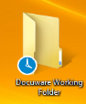DocuWare can accept files from both a scan and email. If a customer emails you a Word, Excel, or other document attachment, first save them to your computer; then drag them into DocuWare. Documents manipulated in Microsoft OneNote must be converted to PDF format before dragging them into DocuWare. To work with documents not scanned into the system, set up a DocuWare Working Folder on your desktop to streamline the process.

#### To set up a new folder on your desktop:

1. Right-click on your desktop and select New>Folder
2. Rename the folder *DocuWare Working Folder*
3. Press Enter on your keyboard. Your new folder displays on your computer desktop.

Move files here when you received them so you can convert them to .pdf, when needed, and drag them into DocuWare.

#### To convert Microsoft Office files to Adobe files:

##### If you do not have Adobe Acrobat Pro on your computer:

1. Save the original document to your DocuWare Working Folder
2. Open the file to convert and choose Save As from the menu option.
3. Select your DocuWare Working Folder by double clicking on it.
4. Name the document and select PDF as the Save as File Type.
5. Save.

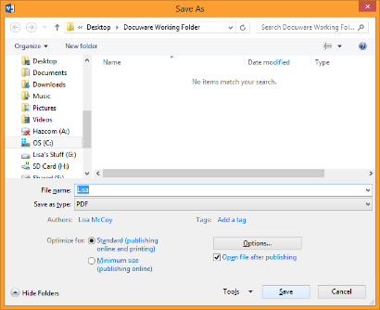

##### If you have Adobe Acrobat Pro on your computer:

1. Save the original document to your DocuWare Working Folder
2. Right-click the document and choose Convert to Adobe PDF
3. Select your DocuWare Working Folder as the Save As location
4. Rename the file, as needed.
5. Save.

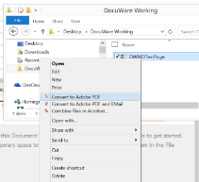

When you’re ready, a document can be dragged and dropped into the DocuWare Document Tray. You have access to Document Trays based on your permissions. Career Office staff have access to one shared Tray for the office they’re in. Career Office Managers and Supervisors have access to two Trays -- the Office Tray and a Confidential Tray. Every Customer Tracking Specialist (Tracker) and all Call Center staff has an individual Tray called, “My Tray” used to manipulate documents for specific applications and files they are working. There are also additional Trays set up to assist with Call Center and Tracking Unit workflow.

To drag a document into a DocuWare Tray:

1. Open DocuWare.
2. Navigate to the file you want to move to DocuWare in Windows Explorer.

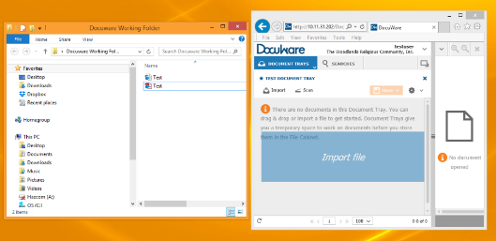

1. Click on the file to import. Remember, the file must be in a standard format -- .docx, .xls, .pdf, .jpg, .tiff, etc. to drag into DocuWare.)
2. While holding your left mouse button, drag the file to the DocuWare Document Tray you’ve chosen until you see Import File in the Tray.
3. Release your mouse button.
4. DocuWare imports the file and displays it in the Document Tray for your office.

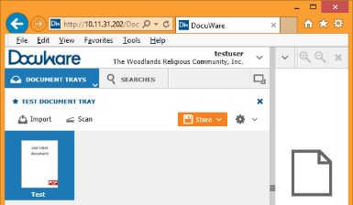

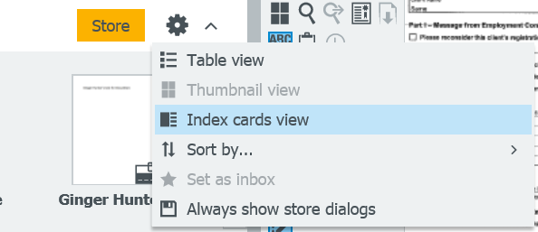Change the way you view documents in your tray by clicking on the Settings icon. A dropdown with view options displays.

## Import files

### *To import files from your computer to DocuWare while in DocuWare.*

From your DocuWare home screen:

1. Select the document Tray to which you wish to import the file by clicking on the Document Tray dropdown at the top left of your screen. The Document Tray displays.
2. Click Import on the top left of the screen. Windows Explorer opens.
3. Select the file to upload and click Open, or double click on the document. The document uploads to the system and appears in the document Tray.

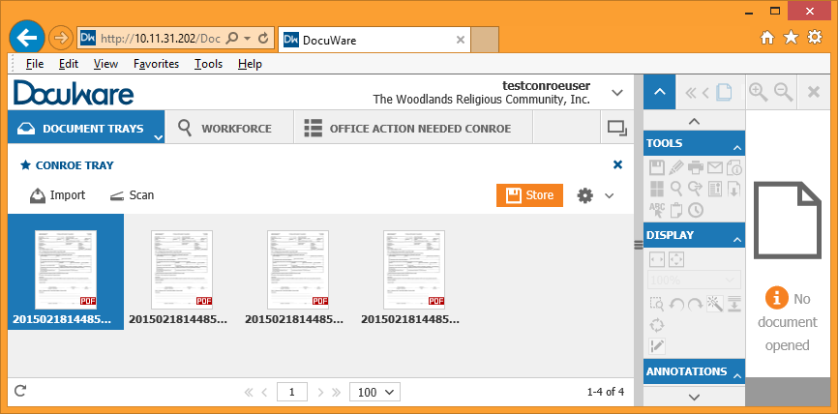

To view documents in DocuWare, simply double click on the thumbnail or record line of the document to open it in the viewer. You can also right-click the line and select Open in New Viewer Window to open an additional viewer with the document displayed.

## Store Documents

Now that you have documents in DocuWare, you must store them in the DocuWare File Cabinet with the appropriate identifiers or indexes. These identifiers allow anyone to locate the files in the system and they help organize the workflow for the Career Office, the Call Center, FAPO, and the Tracking Units. Once files are stored they cannot be removed and can only be stamped Deleted by the Call Center or Tracking Unit.

1. With the document highlighted, click on the Store button. A dropdown list displays your storage options. Career Office staff will only see one option in their dropdown -- ?

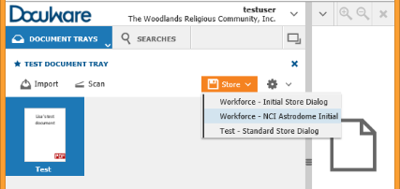

1. Select the appropriate option by clicking on it. The index screen for the File Cabinet displays

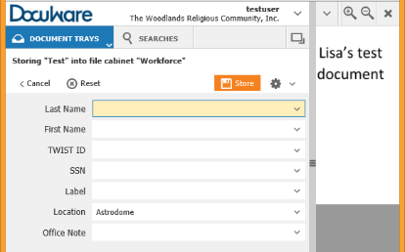

1. Complete all fields.
   1. Last Name, First name required
   2. TWIST ID: Required field, if appropriate for the customer.
   3. SSN: must be entered with no dashes, optional field. Complete if you have it.
   4. Label: Required*
   5. Location: Auto-populates based on your permissions.
   6. *Office Note is optional.*
2. Click Store. The document saves in the File Cabinet.

One Click Indexing allows you to complete index fields by clicking on text on the document in the viewer.

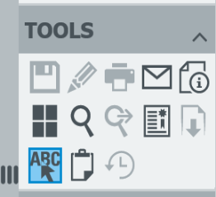

1. Before you select Store, open the document in your viewer.
2. Click on the One Click Indexing icon on the tool bar.
3. Move your cursor to the text in the document where you want to populate the field highlighted on the Index.
4. Click. The information populates the field.

Note: Since the SSN field in DocuWare has only nine characters, a SSN with dashes will not fit the field.

**A Note about Labels**

The Label assigned alerts Call Center or Tracking staff of the document in the system. If the Label is incorrect, the process for approving an application or recording information may be delayed or the document may be missed altogether. Refer to the Appendix for a list of document Labels and an explanation of when to use each. If you make a mistake before saving, remove the Label by clicking on the “X” in the Label field and selecting the correct Label. You cannot change a Label once it has been stored.

# Locate Customer Records

Use the Search tab in DocuWare to locate customer records. DocuWare stores records with up to fifty key indexes which allow you to broaden or narrow your search results. There are two methods to search -- Quick Search and Advanced Search. Only staff with certain permissions have access to Advanced Search.

1. 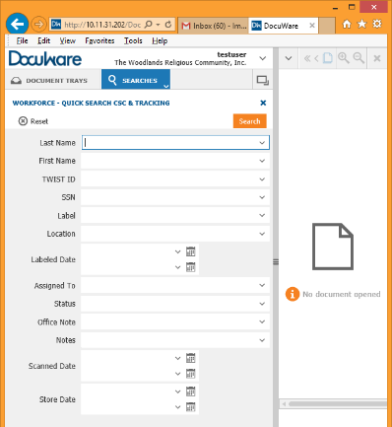Begin your search by clicking on the Searches tab at the top of the screen. The Search screen displays your default search. Click on the Searches dropdown option to choose from the list of your most recent searches.

Quick Searches are set up for different permissions with specific fields available to search.

1. Enter the search criteria you wish to use. You can search using one or multiple indexes. You can search last name and first name with partial information. Other search criteria must be entered completely and accurately. Use an asterisk (*) to indicate missing characters when using search criteria other than name.

***A Note about Searches****: The wildcard, or asterisk*, can be used to substitute characters in any text index. Use this when you have missing or incomplete information. For example if you only have the last 4 digits of a customer’s SSN you can search using the SSN field and *####.*

1. Double click the line to display it in your document viewer on the right side of your screen. You can also right click and choose Open in Viewer. The document displays in the viewer. Use the arrows on the top left of the viewer to scroll through the document pages. Use the scroll slider on the bottom of the search window to scroll through the indexes for the search results.

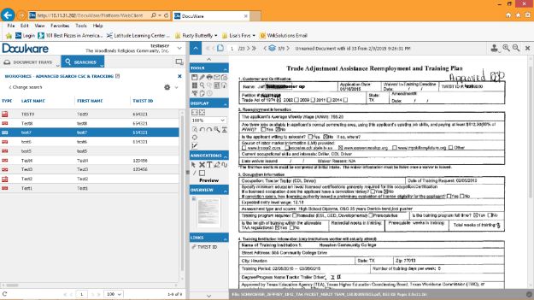

# Edit Indexes

You can edit indexes for saved documents in the file cabinet based on your permissions. Most staff can only edit information in these fields: First Name, Last Name, TWIST, Social Security Number, and Office Note.

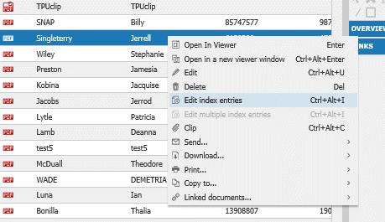

1. Select the document to change by clicking on the line.
2. Right click your mouse.
3. Select Edit index entries.
4. Make changes to the fields, as necessary.

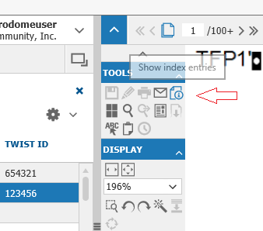If you have the document open in your viewer, click on the Tool icon Show Index Entries.

Important Note: If you discover a customer with multiple TWIST IDs, take the proper steps to have the records merged and notify the Call Center or Tracking Unit of the duplication.

# Add Office Notes to a Document

Use the Office Notes index to communicate with the Call Center or Tracking Unit. You can add Office Notes at any time by editing the index fields. To add Office Notes after a document is saved:

1. Locate the document to which you want to add notes and click on it to highlight or double-click to open in the viewer.
2. Right click and select Edit Index Fields or click on the Edit Index Entries icon in the viewer toolbar.
3. Click the Office Notes field. Add comments.
4. Save.

# Office Action Needed List (replaces Pending list)

Lists are created in DocuWare based on the Labels assigned to a document when it’s stored or when a stamp is applied to the Passport page. You have access to lists based on your permissions in the system. For example, a Career Office user has access only to the Office Action Needed list. The Office Action Needed list displays only documents that need some action by the office staff so Call Center staff or Trackers can move it through the workflow.

Documents that need an action are automatically assigned to the office that uploaded them. The Office Action Needed list is specific to each office. It should be checked periodically during the day to ensure issues are handled in a timely manner, so the Call Center or Tracking Unit can continue working the document. DocuWare

Corrections to a document my require you to scan in a new document, have a document signed and resubmitted, or obtain additional information from the customer. Make the necessary corrections and notify the Call Center by entering Office Notes to the document and TWIST notes, when applicable.

To view lists from your home screen:

* + For Career Office staff, click on the Office Action Needed tab.

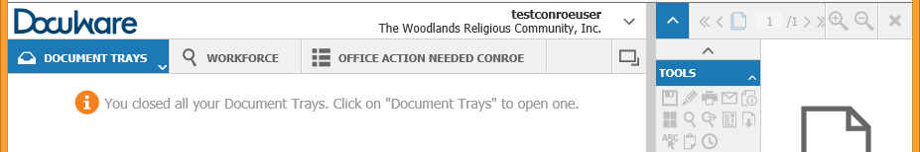

* + For Call Center or Tracking Unit staff, click on the Lists tab; then select Workforce-Office Action Needed CSC from the dropdown.

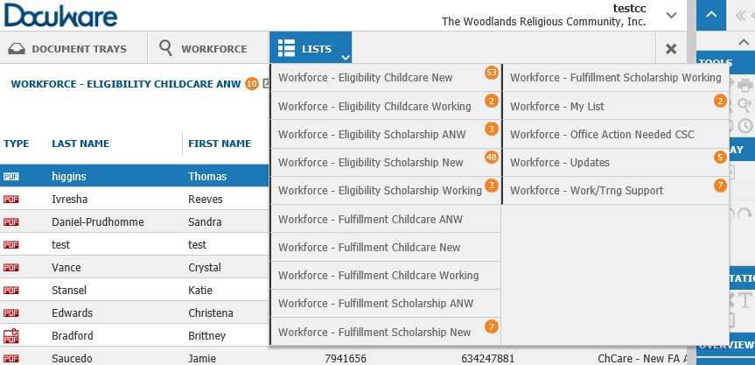

# Working in the Document Tray

The Document Tray is where documents land before they are stored in the file cabinet. It is a public area you use to manipulate documents and pages. Anything in a Tray is not visible by staff outside of your office or group (Tracking Unit or Call Center). Always clear the Tray by storing documents before moving to your next task.

## Combine and Separate Documents

### Unstaple and Split

Once documents are in DocuWare you can manipulate them in a number of ways. Multiple documents scanned together without a Passport page separating them enter the Tray as a “stapled” packet. Only When .pdf documents/packets need to be separated so they can be stored as individual documents, use the staple and unstaple functions to separate and put together pages.

1. Right click on the document in your Tray.
2. Select Unstaple. The pages are separated in the Tray

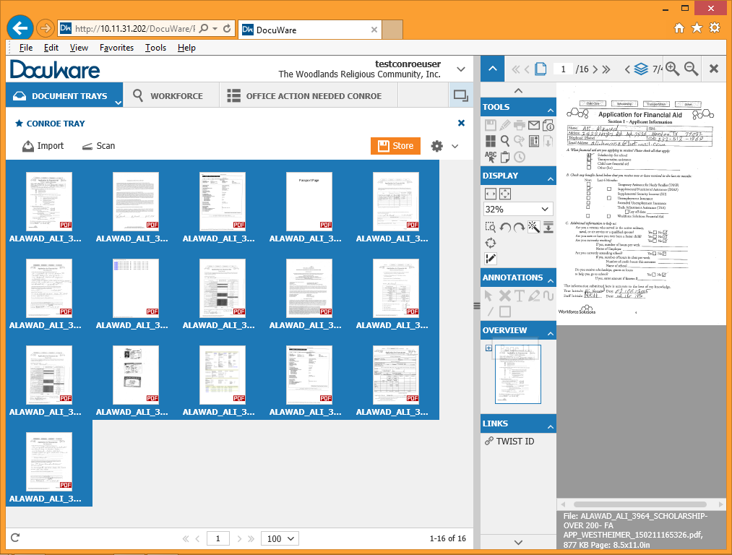

You can also separate documents using the Split tool. Splitting a document separates it into two sections at the point the split is made. To split a document:

1. Open the document in the viewer.
2. Navigate to the page you want to be the first page of the split.
3. Click the Split tool on the top right of the viewer. The document splits and display as two documents in your tray. The second document will have the same name as the first with (2) after it.
4. Store each document with the appropriate indexes.

### Staple

Use the staple function to connect pages of .pdf documents in your Tray.

1. Click on the page you would like to appear first in the document.
2. Hold down the CTRL button on your keyboard.
3. Click on subsequent pages in the order they should be in the documents.
4. Release the CTRL button.
5. Right click and select Staple. The stapled document appears in your Tray.
6. Store the document with the appropriate indexes.

# **Glossary of Terms**

**Area**

**Areas define the accessibility of documents. For example; confidential documents are stored in the confidential area.**

**Auto Index**

**DocuWare automatically puts a document in on a particular index based on criterion selected when it’s stored.**

**Core Document**

**A Label used to ensure certain customer documents, which don’t change, are available anytime the customer applies for financial aid. For example, proof of birth or proof of citizenship.**

**Desktop Apps**

**An application installed from DocuWare that allows additional functionality in DocuWare such as Drag and Drop documents into the DocuWare program.**

**Document Tray**

**A holding place for Items scanned or imported into DocuWare but not yet stored. A place for Call Center staff or Trackers to manipulate documents.**

**File Cabinet**

**Logical container of documents. The name of the file cabinet is Workforce.**

**Function**

**Primary criterion to determine what happens to the document and who sees it. Functions include:**

* + **Auto-Filed**
  + **Deleted**
  + **Eligibility Childcare**
  + **Eligibility Scholarship**
  + **Fulfillment**
  + **Fulfillment Childcare**
  + **Fulfillment Scholarship**
  + **Office Action Needed**
  + **TAA**
  + **Tracking**
  + **Updates**

**Import**

**Using the Import button on top of a Tray in DocuWare brings up a windows file explorer window to select a file to import to that Tray.**

**Import App**

**Used in the background by an import computer to import PDFs to a Tray specified by the import configuration from a scanner (MFP).**

**Index**

**An identifying field, i.e. First Name, Last Name, TWIST ID, SSN.**

**Index fields**

**Used to identify a document so you can search for it in DocuWare. There are up to 50 index fields available.**

**Label**

**Used to identify and route the document scanned to the appropriate place or team. The Label assigns a document to a specific list. For example; 1817s and 2583s are automatically assigned to the Tracking Unit’s list; New Childcare-FA App is automatically assigned to the Call Center team list.**

**Layers**

**Layers tell you if there are additional documents clipped to the original document.**

**Lists**

**Lists group documents according to specified Functions or Labels. Lists are defined by the group that will work with the document. There are 46 defined lists in DocuWare and one ‘My List’ for every Tracker and Call Center user.**

**Paperclip**

**Allows you to clip a document to a document consisting of multiple pages stapled together.**

**Passport Page**

**Used to separate documents when scanning them into DocuWare. It is a blank page titled Passport where Call Center and Tracking Unit staff will stamp documents to move them through the workflow.**

**Search**

**A function on the DocuWare home screen. Searches are set up with index criteria based on permissions. Example of set searches are:**

* **Quick**
* **Advanced**
* **Quick CSC/ Track**
* **Advanced CSC/Tracking**
* **Admin**

**Split**

**You can split a stapled document to insert a new page in the location of the split. You can then staple the sections back together. Use split instead of staple when you have a large number of pages in a document.**

**Stamp**

**Stamps are used to identify actions on a document. Stamps include:**

|  |  |
| --- | --- |
| * + **Approve** | * + **Fulfill** |
| * + **Approve-file** | * + **Move** |
| * + **Confidential (Managers Only)** | * + **Office Action Needed** |
| * + **Delete** | * + **Re-label** |
| * + **Deny** | * + **Work** |
| * + **File** |  |

**Stamp Approved**

**The eligibility team has determined the customer as eligible. The Approved stamp moves the document to the list for the fulfillment team to work.**

**Stamp Approved Filed**

**The eligibility team has determined the customer as eligible. The Approved Filed stamp moves the document to the Filed list. No fulfillment is needed.**

**Stamp Confidential**

**The Confidential stamp puts the document on a list only staff with management permissions can view.**

**Stamp Delete**

**A page or file is not needed or a duplicate. This does not delete the file, but removes it from basic searches and from a monitor’s view. When the stamp is used, the reason for deleting must be documented. A file or document can be permanently deleted only with approval from management.**

**Stamp Deny**

**The eligibility team has determined the customer as not eligible. Staff will be prompted to choose the reason the application is denied.**

**Stamp File**

**Indicates an application or document has been worked and can be filed. This stamp is mainly used by the Tracking Units but may be used when an application has been completed but does not need to be fulfilled.**

**Stamp Fulfill**

**When an application has been completed by the fulfilment team, the document is stamped Fulfill to establish a completion of the process. Documents stamped Fulfill are filed.**

**Stamp Move**

**Overrides the Auto Index by changing a document’s Label or function allowing any open (no completed date) document to move to another List.**

**Stamp Office Action Needed**

**Used on documents added to the Action Needed list for whichever Career Office initially uploaded the document. Specific actions needed will be recorded in the ‘Notes’ field. Response from the office will be typed in the ‘Office Note’ field on the document and an email notification sent to the Call Center or Tracking Unit. Example: Signature Needed.**

**Stamp Work**

**The Work stamp indicates a document is currently being worked.**

**Staple**

**A multi-page document is stored in DocuWare “stapled”. Stapled documents can be “unstapled” so additional pages can be added or so pages can be rearranged. The document can then be stapled back together in a specific order by clicking on the pages in the order they should appear.**

**Wild Card**

**(*) used for Searching. Fills in beginning or end of a string to tell DocuWare to search. Ex. To look for a customer using only the last four digits of his/her SSN enter *#### in the SSN index field. The star alerts DocuWare that characters are missing.**